[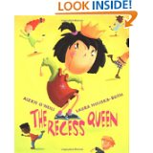](http://www.amazon.com/The-Recess-Queen-Alexis-Oneill/dp/0439206375/ref=sr_1_1?ie=UTF8&qid=1393457328&sr=8-1&keywords=the+recess+queen)

“Mean Jean was Recess Queen  
and nobody said any different.  
Nobody swung until Mean Jean swung.  
Nobody kicked until Mean Jean kicked.  
Nobody bounced until Mean Jean bounced.  
If kids ever crossed her, she'd push 'em and smoosh 'em.”

Mean Jean is the reigning Recess Queen Bully who “pushes, smooshes, hammers and slammers” all the other kids. Each day at recess, Mean Jean bullies her cowering classmates. Then one day, a puny new girl, Katie Sue, joins the class. Katie Sue might be little, but she is not at all intimidated by the school bully. Unaware of the playground hierarchy, the new girl enthusiastically kicks, swings and bounces before the Recess Queen gets the chance to start bullying her. Imagine everyone’s surprise when Katie Sue innocently invites Mean Jean to play with her – something no one else has ever dared to do. At first Mean Jean is caught off guard with the invitation, but in no time flat, Jean (notice she loses the label, “Mean”) are best buddies and once again the playground is fun and safe for everyone.

It would be wonderful if all bullying problems could be solved this easily, and while the plot of this story is simplistic, there is a strong element of truth in this tale. One thing readers might learn is that bullies are people, too and sometimes all they really want is a true friend.

[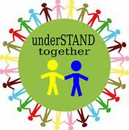](http://www.bing.com/images/search?q=+bully++Clipart&qs=n&form=QBIR&pq=bully+clipart&sc=0-0&sp=-1&sk=#view=detail&id=CF3EEF6C9C818C4AD199F7F1A64D693141003608&selectedIndex=10)It takes the entire school community to create an inviting environment where everyone feels they belong and are safe. Working together, administrators, teachers, school staff, parents, and students can help provide harmony in our schools.

**After reading The Recess Queen, we will:**

* Identify people in our schools and community who can help solve problems such as bullying;
* Discuss the responsibilities of individuals in schools (e.g., respect for the rights and property of others, tolerance, honesty, self-control, compassion, fairness, etc.).

**Potential Activities**

**Is It Tattling or Is It Telling?**

* Talk to students about what makes them feel safe at school.
* Ask students to share their own definitions of or experiences with bullying.
* Read and discuss The Recess Queen.
  + Do you think Mean Jean was a bully?
  + What happened that helped Mean Jean change?
  + What did Katie Sue do to make a difference in the way the other students felt about Mean Jean?
  + Why did this stop Mean Jean from bullying others?
    - most bullies really want to have friends, but don’t know how to make friends, however, talking and playing with a bully does not always work.
  + [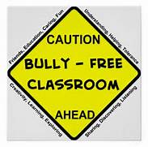](http://www.bing.com/images/search?q=+bully++Clipart&qs=n&form=QBIR&pq=bully+clipart&sc=0-0&sp=-1&sk=#view=detail&id=072386B570DCFFA20D283765D8912FF282D1105B&selectedIndex=36)Why did the author change Mean Jean’s name?
  + Help students understand the differences between tattling and telling
  + Chart three strategies for dealing with a bully:
    - Walk
    - Talk or
    - [](http://www.bing.com/images/search?q=lines++Clipart&qs=n&form=QBIR&pq=lines+clipart&sc=4-13&sp=-1&sk=#view=detail&id=06C78D56A4BF825DC0D152EB1B6D3D0468DEDA01&selectedIndex=0)Tell

**The Recess Queen Readers Theatre based on the book by Alexis O’Neill**

**Characters:** Mean Jean Katie Sue Student 1 Student 2 Student 3 Narrator

**The Script**

ALL: Mean Jean was The Recess Queen!

Mean Jean: And nobody said any different!

Narrator: If kids ever crossed her, she’d push them!

Student 1: Smoosh them!

[](http://www.bing.com/images/search?q=stage+clip+art&qs=n&form=QBIR&pq=stage+clip+art&sc=8-14&sp=-1&sk=#view=detail&id=ACE593C53E3F92575D873544AB4D647517E04639&selectedIndex=4)Student 2: Hammer them!

Student 3: Slammer them!

Mean Jean: Say what?

ALL: Jean growled.

Mean Jean: Say who?

ALL: Jean howled.

Mean Jean: Say you!

ALL: Who do you think you’re talking to?

Narrator: Mean Jean always got her way until...

Student 1: One day a new girl came to school.

Student 2: Katie Sue. She was so tiny you could scare her with a

ALL: BOO!

Student 3: When the recess bell went

ALL: Ringity-ring!

Katie Sue: I ran zingity-zing!

Narrator: She swung ﬁrst!

Student 1: She kicked ﬁrst!

Student 2: She bounced ﬁrst!

Student 3: The same girl who you could scare with a

ALL: BOO!

Narrator: Was too new to know about Mean Jean

ALL: The Recess Queen!

[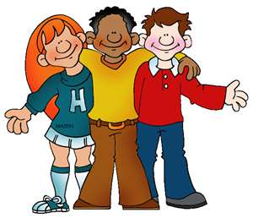](http://www.bing.com/images/search?q=Free+School+Clip+Art&view=detail&id=DD55970FAA40DCFD2FC841C70C55D8ADF9A204C5&first=271&FORM=IDFRIR)Mean Jean: Well, I bullied through the playground crowd

Student 1: And charged after Katie Sue!

Mean Jean: Say what?

ALL: Jean growled.

[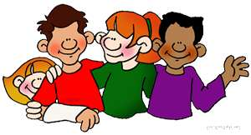](http://www.bing.com/images/search?q=teenagers+clip+art&view=detail&id=113D8C0D4F82F17104C28F66616C910CD6FB507F&first=91&FORM=IDFRIR)Mean Jean: Say who?

ALL: Jean howled.

Mean Jean: Say you!

ALL: And she gored she set the record straight with Katie Sue.

Katie Sue: Well, you ﬁgured wrong!

Student 2: Katie Sue talked back!

Student 3: And super sassy, she said:

Katie Sue: How DID you get so bossy?

ALL: And she grabbed the ball and ran away!

Mean Jean: I thundered close behind!

Narrator: The Recess Queen was NOT amused!

Student 1: She raced and chased

Student 2: And in your faced Katie Sue.

Student 3: No one spoke.

Narrator: No one moved.

ALL: No one breathed.

**[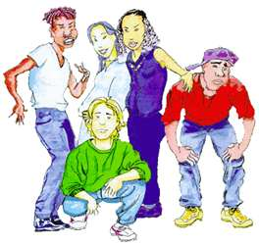](http://www.bing.com/images/search?q=teenagers+clip+art&view=detail&id=B245EC7A317A1C7792D45164509ECE0D070C04AA&first=0&FORM=IDFRIR)**Mean Jean: Then Katie Sue pulled a jump rope from her pack

Katie Sue: Hey Jeanie Beanie! Let’s try this jump rope out!

Student 1: No one had ever

[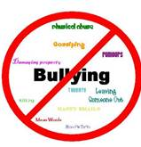](http://www.bing.com/images/search?q=bully+clip+art&qs=n&form=QBIR&pq=bully+clip+art&sc=8-14&sp=-1&sk=&adlt=strict#view=detail&id=85C9342C0F31AA82FC662BBC03307A16BD7C7494&selectedIndex=28)ALL: DARED

Student 2: To ask Mean Jean to play.

Student 3: Katie Sue skipped away and sang:

Katie Sue: I like ice cream, I like tea, I want Jean to jump with me!

Narrator: Jean just stared!

ALL: Like she was SCARED.

Student 1: Then someone yelled out:

ALL: Go, Jean, Go!

Student 2: And too surprised to even shout

Student 3: Jean jumped in and sang along.

Mean Jean: The rope went faster!

Katie Sue: And faster!

ALL: And faster!

Narrator: Till it caught in a disaster!

Mean Jean and Katie Sue: We just giggled!

ALL: And jumped again!

Student 1: Well, now when recess rolls around

Student 2: The playground is one great place!

Student 3: Jean doesn’t push kids

Katie Sue: Or smoosh kids!

Mean Jean: Because I’m having too much fun

ALL: **Playing with her FRIENDS!**

**Bully ‐Free Zone Song!**

[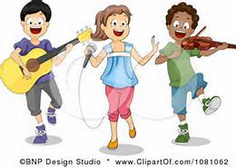](http://www.bing.com/images/search?q=kids+singing+clip+art&qs=n&form=QBIR&pq=kids+singing+clip+art&sc=3-21&sp=-1&sk=&adlt=strict#view=detail&id=A14FC27CFCA921A4BD2685710026F9EE271964EA&selectedIndex=60)**Introduction**  Attention please! May I have your attention please!  This is a BULLY‐ FREE ZONE! I repeat, a BULLY‐ FREE ZONE!  No bullying will be tolerated in this school, it's a BULLY‐FREE ZONE!

**Verse 1**    Bullying is a cowardly act, ‘abuse’  is how it's rated.   In our school there is a rule, it won’t be tolerated!    Everyone must play a part, to keep  it safe and friendly‐  Hear the message loud and clear ‐ you're not allowed to bully!

**Chorus** Bullying is not OK ‐ NO WAY! It's never a solution,  Deal with problems as they rise with conflict resolution.  Caring isn't optional, it's what we all expect;  Everyone is welcome here, but bullying we reject!

**Verse 2**  Everyone is valued here and all must be protected.   Negative behavior at all times will be rejected!  Trying to annoy someone does not build good relations,   It's a form of what is known as private space invasion.

**Chorus**

**Verse 3**  Gossiping and being mean, and making others tearful;   Pushing, pinching, ganging up, and making others fearful;   Nasty emails, SMS, and other cyber teasing,  Never can be justified, there's never a good reason! .

**Chorus**

**Verse 4**  Always think about the way another might be feeling.   Show respect for property ‐ no damaging or stealing!   If someone is bullying you, then it must be reported,  That's the only way that bad behavior can be sorted.

[](http://www.bing.com/images/search?q=friends+clip+art&qs=n&form=QBIR&pq=friends+clip+art&sc=8-15&sp=-1&sk=&adlt=strict#view=detail&id=617F18ED7FDF8484DECE6BB75060BDF16654D1E2&selectedIndex=10)**Chorus**

So tell me, what is it? A BULLY‐ FREE ZONE,

yeah, yeah, it s a BULLY‐FREE Zone!

© 2009 Lyrics by Nuala O’Hanlon/Music by Kathryn Radloff  Published by Keystone Creations Pty Ltd

[](http://www.bing.com/images/search?q=lines++Clipart&qs=n&form=QBIR&pq=lines+clipart&sc=4-13&sp=-1&sk=#view=detail&id=06C78D56A4BF825DC0D152EB1B6D3D0468DEDA01&selectedIndex=0)

* Students could write a letter to Mean Jean explaining to her about fairness and how she is not being fair to others.
* Students could design, distribute and analyze the results of a survey about bullying in our schools.
* Group members could create and post an anti-bullying motto for our schools.
* Students could write a letter to a student who was bullied by Mean Jean to suggest to them how they could have solved the problem.
* Students could construct a multi-flow map to show cause and effect of how Mean Jean’s behavior led to the way others treated her. (The kids avoided her and did not want to play with her because she was so mean, but Katie Sue included her and therefore she decided to be nice).
* Compare/Contrast; construct a double-bubble map comparing and contrasting Katie Sue and Mean Jean.
* Name Rhymes- Instead of “Mean Jean”, students can take their own names and put a rhyming word that describes them in front of it. If they cannot think of a rhyming word for their name they could do a word that begins with the same letter as their name and write a poem about themselves and why this word describes them.
* Students might write about a time they were in an unfair situation and how they solved their problem.
* Students could create a Fair/Not Fair- make a T-chart of situations that are fair/not-fair.
* Older students could examine groups from generations past that experienced unfairness, such as segregation, slavery, religious persecution, etc.
* As a group, students could create a list of playground rules to review procedures.
* Group members could make a T-chart of Tattling vs. Telling situations for bullying and understanding.
* As a group, brainstorm some recess games that would include everyone.

[](http://www.bing.com/images/search?q=lines++Clipart&qs=n&form=QBIR&pq=lines+clipart&sc=4-13&sp=-1&sk=#view=detail&id=06C78D56A4BF825DC0D152EB1B6D3D0468DEDA01&selectedIndex=0)

**How a Bully Feels**

People who bully sometimes feel bad about themselves. The bully is hiding how they really feel when they act like a bully. Look at the pictures below. What could be done to make the bullies act different and feel better?

**No one likes to play with me anyway. I will just be mean to everyone.**

**I do not know how to do the work in class. I will be mean so the other kids will not laugh at me.**

[](http://www.bing.com/images/search?q=boy++Clipart&qs=n&form=QBIR&pq=boy+clipart&sc=8-11&sp=-1&sk=#view=detail&id=DC6F931E88C1EAA3AB1F7706BA03A2C8E1B56CB9&selectedIndex=54)[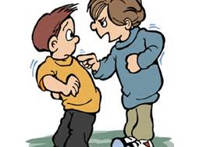](http://www.bing.com/images/search?q=bully+girl++Clipart&qs=n&form=QBIR&pq=bully+girl+clipart&sc=0-14&sp=-1&sk=#view=detail&id=D0878A9F21F05B35D0C548B4A7F317A779CD3EDF&selectedIndex=11)

|  |  |
| --- | --- |
| **What Could They DO Differently?** | **What Could You DO to Help?** |
|  |  |
|  |  |
|  |  |
|  |  |

[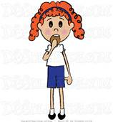](http://www.bing.com/images/search?q=girl++Clipart&qs=n&form=QBIR&pq=girl+clipart&sc=8-12&sp=-1&sk=#view=detail&id=77400EF02864DA6260F33665B2960320A829847A&selectedIndex=31)

**Sarah will not be my friend if I do not act like a bully.**

[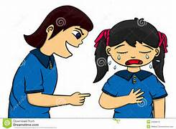](http://www.bing.com/images/search?q=bully+girl++Clipart&qs=n&form=QBIR&pq=bully+girl+clipart&sc=0-14&sp=-1&sk=#view=detail&id=134CF341826999B531B728A521D4493362C9A7E0&selectedIndex=26)

**If I do not tease John, my friends will not play with me.**